***Directions: Provide a snippet of each figure in the tutorials below.***

**Tutorial 6-1 (Pg. 380):**

1. Figure 6-4:

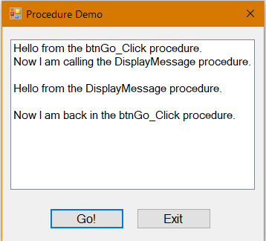

**Tutorial 6-2 (pg. 383):**

1. Figure 6-6:

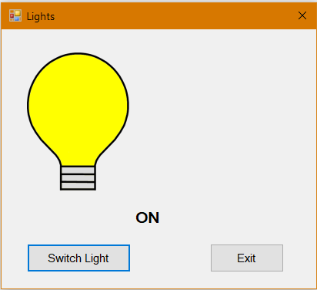

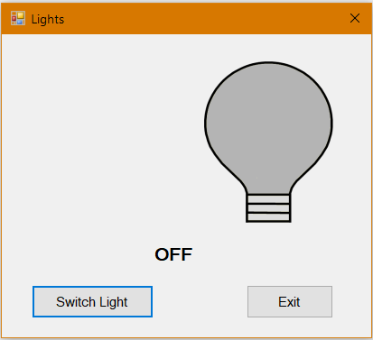

**Tutorial 6-3 (pg. 389):**

1. Step 8:

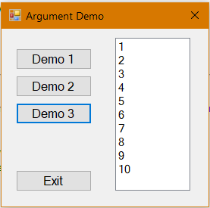

***Continuation of Snippets:***

**Tutorial 6-4 (pg. 392):**

1. Figure 6-13:

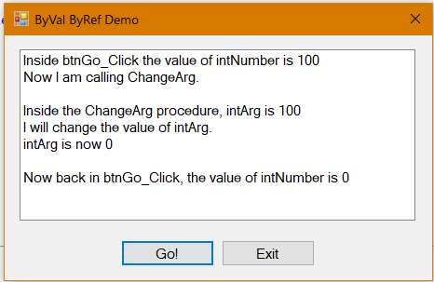

**Tutorial 6-5 (pg. 396):**

1. Figure 6-16:

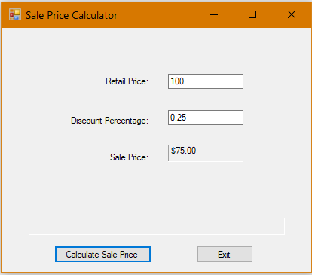

**Tutorial 6-6 (pg. 404):**

1. Step 6:

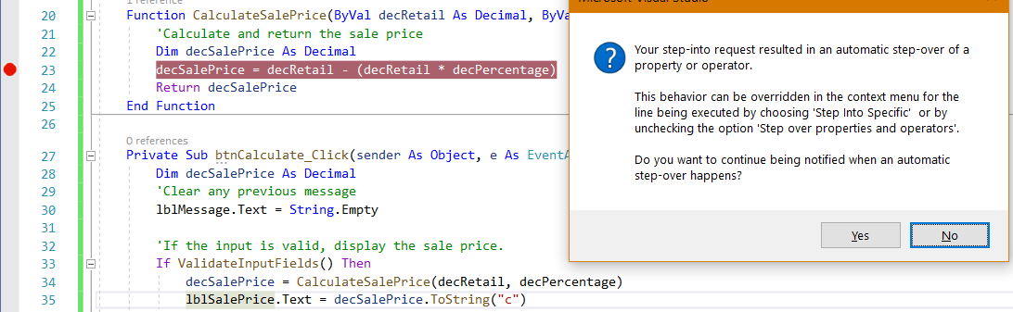

***Continuation of Snippets:***

**Tutorial 6-7 (pg. 405):**

1. Step 4:

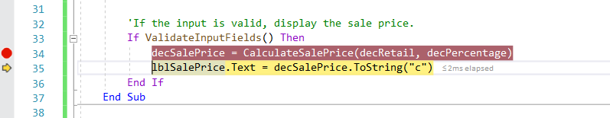

**Tutorial 6-8 (pg. 406):**

1. Step 6:

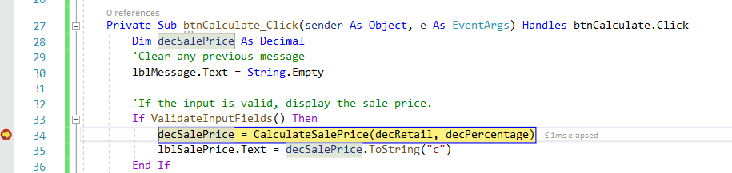

**Tutorial 6-9 (pg. 412):**

1. Snippet of the code after step 5:

